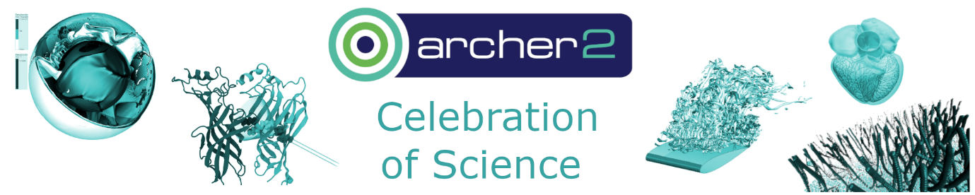
ARCHER2 Celebration of Science
Poster Abstract Submission Form
The ARCHER2 Celebration of Science will take place in Edinburgh on the 7th - 8th March 2024.
To submit a poster please complete this abstract submission form, in full, and then email the completed form to events@archer2.ac.uk by 23rd January 2024.
Notifications of acceptance will be sent out by 6th February 2024.
An electronic version of your poster (PDF file) should be submitted to events@archer2.ac.uk by 7th March 2024.

Your details
Forename
Surname
Email address
Institution
ORCID
If known
Names, Institutions, and ORCIDs (if known) of all additional authors

Poster details
Title
Keywords
Science Area
E.g. Chemistry & Materials, Earth Sciences & Environment, Engineering & Energy, Fundamental Physics, Mathematics & Computer Science, Medicine & Life Sciences, Other (please specify)
Abstract
Max 250 words
summarising the content of the poster
Target Audience (optional): Describe how the submission is of interest to the event attendees / ARCHER2 community and any specific target audience.
eCSE Project ID(s)
If applicable
eCSE Project Title(s)
If applicable

Declaration
☐ | I/we declare that this is my/our own original work and I/we agree to the content of the poster being published online and added to the ARCHER2 repository on Zenodo (https://zenodo.org/communities/archer2).
☐ | I/we would like the ARCHER2 team to obtain a DOI (Digital Object Identifier) for my/our poster.  If yes, please confirm the licence to use. The default licence is Attribution-NonCommercial-NoDerivatives 4.0 International (CC BY-NC-ND 4.0). If any other licence is preferred, please state it here. If you already have a DOI for this poster, please also indicate it here.

